Name: Kainaat Rafiq Hussain Makhani
Registration #: 2012296
Semester and Section: 7A
LAB 7
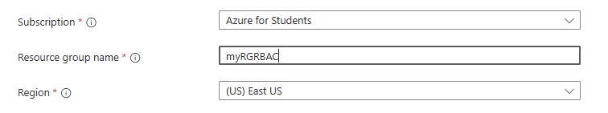

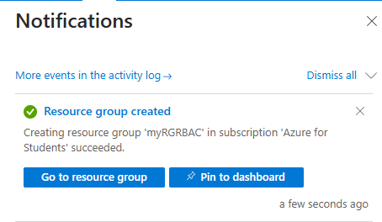

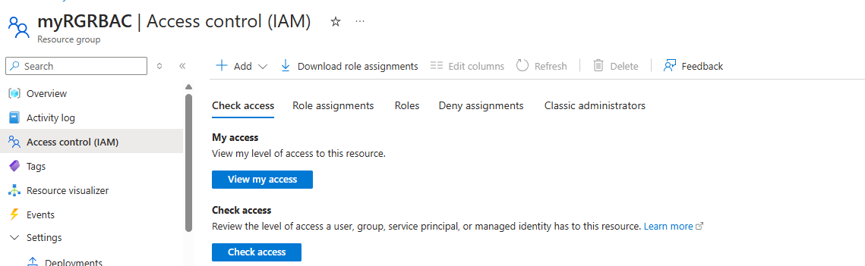

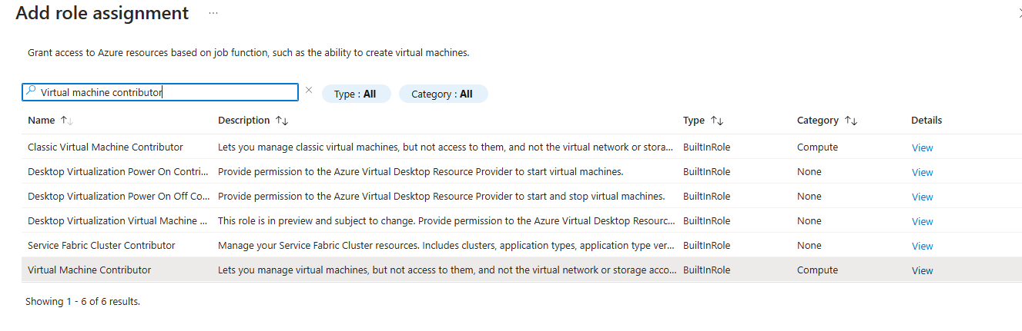

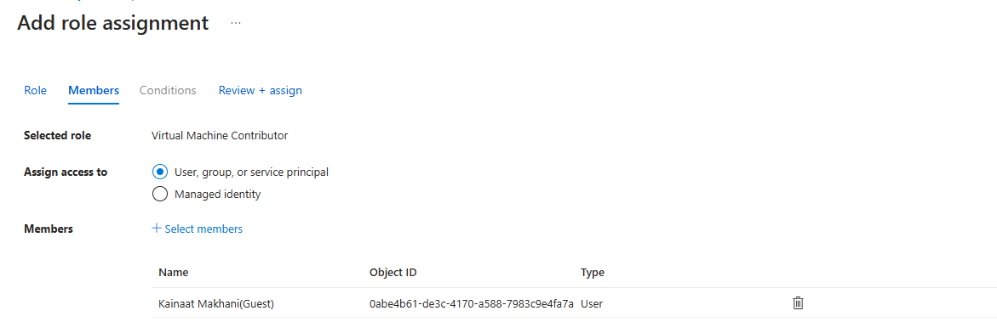

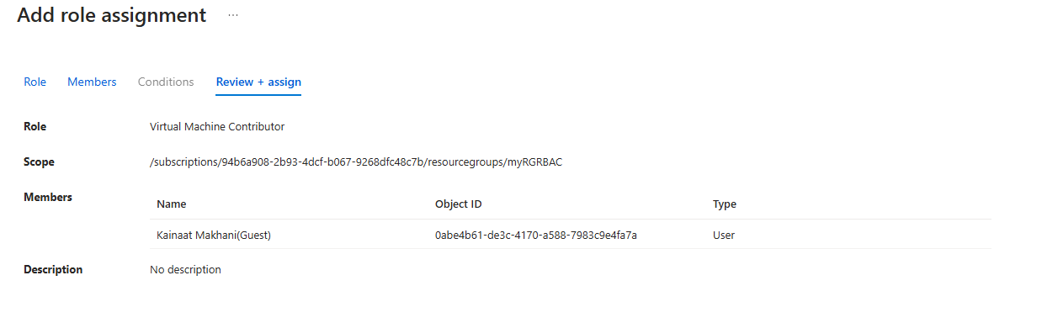

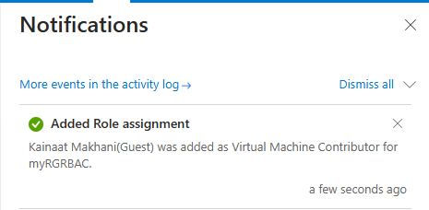

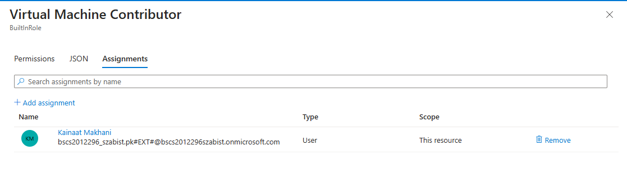

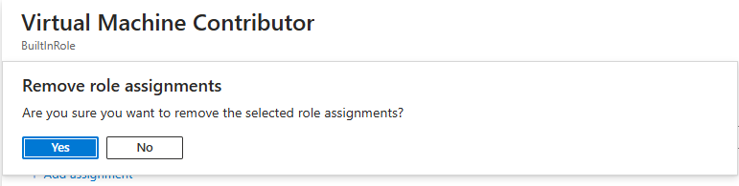

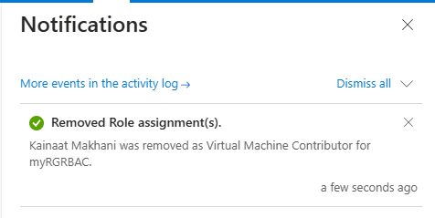

Description:
This lab focuses on managing user identities, assigning and removing roles, and implementing governance and compliance features in Microsoft Azure. Students learn how to create users, assign appropriate roles using role-based access control (RBAC), and manage permissions. The lab also covers how to review activity logs and monitor access. It helps understand the importance of least privilege access and accountability in cloud environments. This ensures better security and compliance with organizational policies.

